Context

AMP6 (2015-2020). Chris Chambers (Group Treasurer, Wessex Water)

Year available from Consented Discharges

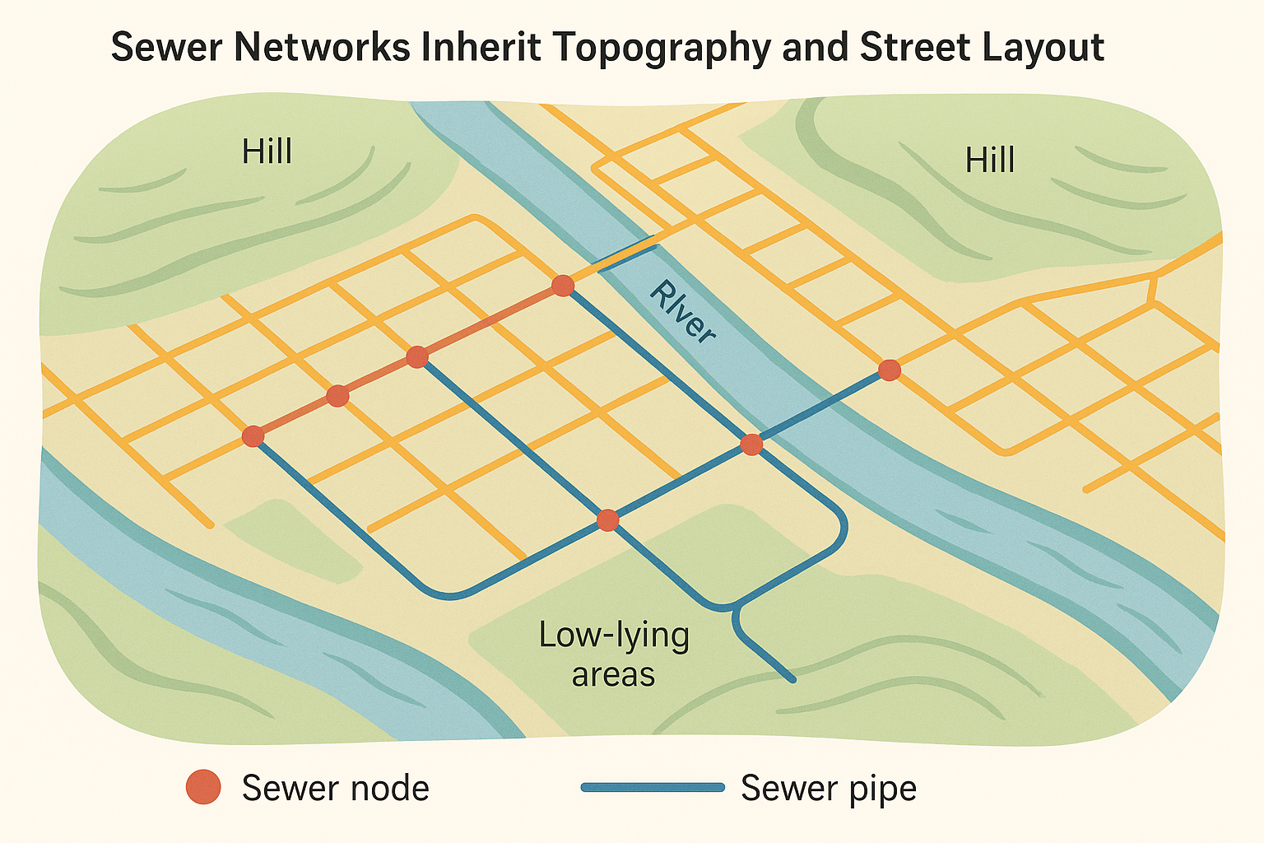

Causality

Hydrological boundary discontinuity -- in top quartile

Original placement – sinks, major street junctions, distance to WwTW and river.

News stories or rollout of EDMs/Alerts from SAS

Rainfall as instrument for Spills, if can show not also correlated with flooding events

Counterfactuals

More storage tanks

Thames Tideway Tunnel

DWMP

